COVID-19/At-Home Mental Health Resource List

Fact Sheets
- CDC Managing Stress and Anxiety during COVID-19 Pandemic https://www.cdc.gov/coronavirus/2019-ncov/prepare/managing-stress-anxiety.html
- CDC Preparedness resources https://www.cdc.gov/coronavirus/2019-ncov/php/pandemic-preparedness-resources.html
- NASP Talking to children about COVID-19 (multilingual resources available) https://www.nasponline.org/resources-and-publications/resources-and-podcasts/school-climate-safety-and-crisis/health-crisis-resources/talking-to-children-about-covid-19-(coronavirus)-a-parent-resource
- NCTSN Caregiver COVID-19 Preparedness fact sheet https://www.nctsn.org/sites/default/files/resources/fact-sheet/outbreak_factsheet_1.pdf
- SAMSHA Taking care of behavioral health during an infectious disease outbreak https://store.samhsa.gov/product/Taking-Care-of-Your-Behavioral-Health-During-an-Infectious-Disease-Outbreak/sma14-4894

Crisis and Hotlines
- Call 911 if you are in danger and in need of immediate help
- List of common hotline numbers (USA only) https://psychcentral.com/lib/common-hotline-phone-numbers/
- Support, mobile crisis, referrals, suicide prevention by talk/text/chat through NYCWell 1-888-NYC-Well (1-888-692-9355); Text: “Well” to 65173; Chat: nyc.gov/nycwell
- Gender-Based Violence/Domestic Violence coping and support https://www.safehorizon.org/emergency/
- NYC Domestic Violence and Sexual Assault Hotline at 800-621-4673 (HOPE), TTY: 866-604-5350 (if you are hearing impaired), or call 311 and ask for the hotline

Teletherapy
- To find a therapist, search https://www.psychologytoday.com/us/therapists and filter by therapists who offer teletherapy
- Type therapy (just put in therapy) in the search bar on https://theshrinkspace.com/. When you get to the result page, use the more tab (usually it is the last tab on the top). Filter under the Therapeutic Modality - online and click apply. Fordham students sign up with Fordham email.
- Teletherapy headway.co: All Headway therapists accept insurance for teletherapy sessions, and Headway automatically calculates copays & deductibles for patients with their insurance member ID
- 1 free coaching session for freelancers, artists, and entrepreneurs struggling with the impact of COVID-19 on their professions https://calendly.com/lisa-husseini/covid?month=2020-03
- Free teletherapy for healthcare workers via spiritof1848.org providers, fill out questionnaire: https://forms.gle/axuxuGCnjqwwqRks5
- 7 Cups of Tea: Free online peer counseling trained in active listening https://www.7cups.com/

Support Groups
- Virus Anxiety Toolkit https://www.virusanxiety.com/
- NAMI online support groups and hotline for people with mental illness and for caregivers and friends of people with mental illness https://www.nami.org/getattachment/Press-Media/Press-Releases/2020/COVID-19-and-Mental-Illness-NAMI-Releases-Importan/COVID-19-Updated-Guide-1.pdf?lang=en-US
- Virtual Support Groups at Mountainside.com:for people in addiction recovery, groups for loved ones of people in recovery and a group for first responders + healthcare workers https://mountainside.com/about-us/events/virtual-support-groups
- Turn2Me online support groups https://turn2me.org/group-supports
- +sg support groups https://www.supportgroups.com/online
- Eventbrite can be searched for online COVID-19 support groups, like https://www.eventbrite.com/e/online-covid-19-support-group-tickets-100052716368
- Daily Strength: An active online support group for anxiety https://www.dailystrength.org/group/anxiety
- The Tribe online anxiety peer-to-peer support group https://support.therapytribe.com/anxiety-support-group/
- QueersOnZoom: LGBTQ+ community support http://bit.ly/QueersOnZoom
- LGBTQ community support on Slack and virtual hangouts by Out in Tech https://linktr.ee/outintech or on instagram at @outintech and @hellomynameiswednesday
- Online sobriety resources can be found by googling AA, NA, Al-Anon, Tempest, and In the Rooms
- Many support groups for specific groups and concerns exist on Facebook and meetup.com. Try searching depression support, [identity group] support, [name of your city or locality] support, etc. Groups for COVID-19 support for specific neighborhoods are also popping up more and more on Facebook.

Family Resources
- Child Mind telehealth and mental health resources for children and adolescents: 212-308-3118 or childmind.org
- How to set healthy boundaries (tips and worksheets) https://positivepsychology.com/great-self-care-setting-healthy-boundaries/ and https://www.healthline.com/health/mental-health/set-boundaries#boundary-basics-and-benefits
- Dealing with toxic family members https://www.mindbodygreen.com/articles/heres-how-to-deal-with-toxic-family-members
- How to talk to family and friends about your mental health needs https://www.nami.org/find-support/living-with-a-mental-health-condition/disclosing-to-others
- How to get alone time when at home with family https://herviewfromhome.com/how-to-make-personal-time-when-you-are-never-alone-this-tip-changed-my-life/ and https://www.purewow.com/family/how-to-get-alone-time-surrounded-by-family
- Resources for parents on how to provide support for their children
https://www.childtrends.org/publications/resources-for-supporting-childrens-emotional-well-being-during-the-covid-19-pandemic and https://www.nasponline.org/resources-and-publications/resources-and-podcasts/school-climate-safety-and-crisis/health-crisis-resources/talking-to-children-about-covid-19-(coronavirus)-a-parent-resource

Relaxation and General Coping Resources
- Coping with social isolation: https://psychcentral.com/blog/quarantine-quandaries-how-to-beat-the-hum-drum-of-isolation/ and https://blogs.psychcentral.com/narcissism/2020/03/tips-for-self-isolation-heres-how-to-be-happy-being-home-24-7/
- Apps: Stressbusters, CalmHarm (for SI/SH), Clear Fear (for anxiety attacks and dissociative episodes), What’s Up, Mind Shift
- NYT The Calm Place https://www.nytimes.com/2018/11/05/style/self-care/the-calm-place-on-the-internet.html
- Many yoga studios and gyms are offering reduced rate online versions of their regular classes -- reach out to your local gym or studio for info!
- Zoom/live video meditation and yoga classes https://www.spiritual-alignment.com/classes.html
- Free yoga, guided meditation, exercise classes are available on YouTube and wherever podcasts are found (e.g., Three Dog Yoga, Quietmind Yoga, Power of the Om, AMYoga, Embraced Podcast).
- Ashtanga Yoga NY classes on Zoom and Instagram (free/donation) at www.eddiestern.com
- Mental health podcasts by women of color https://www.justdavia.com/blog/5-mental-health-podcasts-by-therapists-of-color
- Coping skills worksheets and toolkit https://www.bcbe.org/cms/lib/AL01901374/Centricity/Domain/1760/Coping%20Skills%20Toolkit.pdf
- Acceptance and Commitment Therapy (ACT) videos (for anxiety, depression, OCD, low self-worth, etc.) https://contextualscience.org/free_videos_learning_about_and_applying_act
- ACT book chapters and worksheets https://www.actmindfully.com.au/free-stuff/worksheets-handouts-book-chapters/
- Free month of courses on The Great Courses -- some are mental-health or coping related https://www.thegreatcoursesplus.com/
- Online Art Therapy https://www.ifyouwereherenow.art/
- Information from NAMI (National Alliance on Mental Illness) on COVID and how to deal with the situation
https://www.nami.org/getattachment/About-NAMI/NAMI-News/2020/NAMI-Updates-on-the-Coronavirus/COVID-19-Updated-Guide-1.pdf

Arts & Entertainment
- Virtual COVID-19 Concert Building: Group for artists to share and build online performances, and for patrons to find online concerts to attend https://www.facebook.com/groups/covidartistpatronalliance/
- Gibney dance and exercise classes, support for professional artists https://mailchi.mp/gibneydance/coronavirus-resources
- StayAtHome Festival https://stayathomefestival.com/
- Social Distancing Festival https://www.socialdistancingfestival.com/
- Virtual mini-Indian classical arts camp https://navatmaninc.thundertix.com/
- Online streamed dance classes & dance community: https://www.dancingalonetogether.org/
- Free online courses at ivy league universities https://www.freecodecamp.org/news/ivy-league-free-online-courses-a0d7ae675869/

Financial Resources
- Remote job opportunities https://covid19freelanceartistresource.wordpress.com/?ref=spelling#JOBS
- Many people are looking for childcare -- ask around in your networks or on Facebook!
- All NYC schools are offering families free pick-up and go breakfast and lunch. Call 311 or use the NYC school finder for your nearest school: https://www.nycenet.edu/schoolsearch?fbclid=IwAR3U-w8ccj28f1HJcbArY0hWLg2Ml24diYODkqkElMLO9Aj-Q4QNchS49uw
- Financial resources for artists and performers (including SNAP and welfare info) https://mailchi.mp/gibneydance/coronavirus-resources
- Funding resources for artists https://creative-capital.org/2020/03/13/list-of-arts-resources-during-the-covid-19-outbreak/
- National Performance Network resource list https://mailchi.mp/npnweb/npn-needs-partner-logos-for-website-deadline-wed-oct-23rd-1398528
- Freelancers Union https://covid19freelanceartistresource.wordpress.com/

For Mental Health Clinicians
- APA Telepsychology Guidelines https://www.apa.org/pubs/journals/features/amp-a0035001.pdf
- APA Supervision Guidlines https://www.apa.org/about/policy/guidelines-supervision.pdf
- APA CE Office: Resources on Telehealth https://www.apa.org/ed/ce/telehealth
- APA COVID-19 Healthcare Professional Resources https://www.apa.org/practice/programs/dmhi/research-information/pandemics

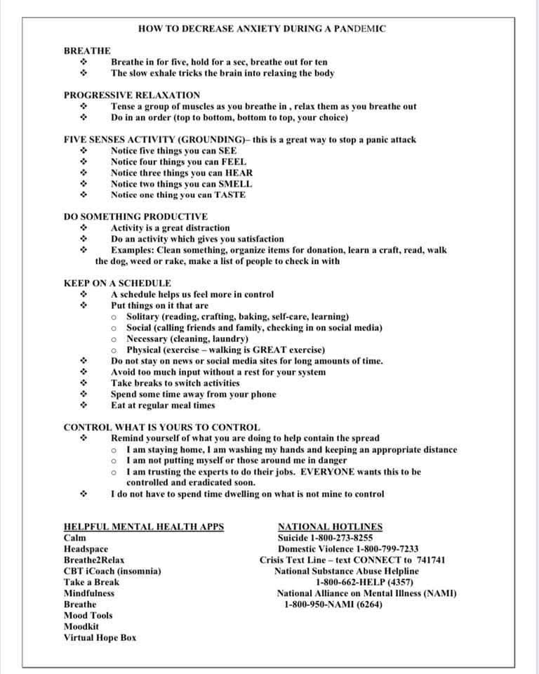

Thank you Eunice Kim-Skenderian, Sydney Ji, and Tabitha Sukhai for recommendations :)

