Preschool Resource

Coronavirus & COVID-19:
What you need to know

This resource sheet contains:
- Talking points for young children
- Four pictures that can be shown on a screen or printed for showing at circle time
- Additional resources

Objectives:

Students will learn about:
- Coronavirus and COVID-19
- Ways to keep themselves, their families, and their communities healthy

Talking Points:

- Have you heard the adults at home talking about the germ called Coronavirus? It is a very, very small germ. It can make people sick with something called COVID-19.
- Because people are sick, you will not be going to school for two weeks. We want the healthy people to stay healthy!
- You can help stay healthy by:
  - Washing your hands (Page 3)
    - Let’s go over how to wash our hands:
      - Turn on the water.
      - Soap your hands.
      - Rub your hands together, between your fingers, under your nails, on the backs of your hands.
      - Rinse your hands under the water.
      - Dry your hands with a paper towel.
      - Turn off the water with your paper towel.
    - Sing the Happy Birthday Song two times through when you wash your hands. Let’s practice now.

    - When should you wash your hands? (Page 4)
      - When you get home
      - After you play
      - Before and after you eat
      - After you play with your pets

  - Sneezing or coughing into your elbow, so the germs stay near you, and not others. (Page 5)
    - Let’s practice sneezing or coughing into our elbow.
  - Keeping your hands away from your face. (Page 6)
    - DON’T pick your nose, rub your eyes, or put your fingers in your mouth.
    - DO:
      - Wash your hands often with soap and water
      - Sneeze or cough into your elbow
      - Keep your hands away from your face
- Let’s Review!
  - What are 3 DO’S?
    - Wash your hands
    - Sneeze or cough into your elbow
    - Keep hands away from your face
  - What are 3 DONT’S?
    - Don’t pick your nose
    - Don’t rub your eyes
    - Don’t put your fingers in your mouth

Additional Resources:

TK-1 Coronavirus & COVID-19 Slide Presentation

Handwashing video in English/children
Handwashing video in Spanish/children
Handwashing video in Cantonese/adults

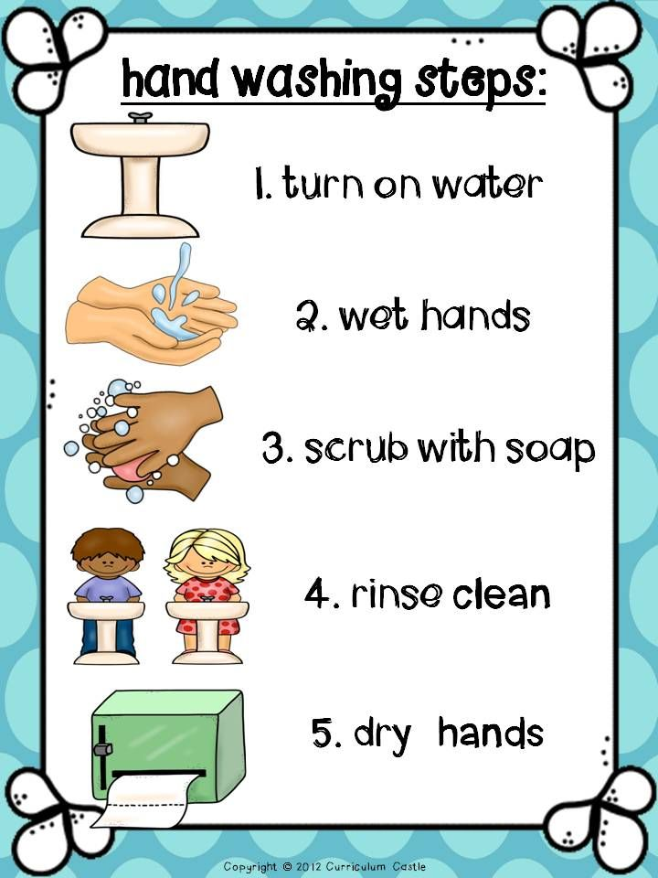
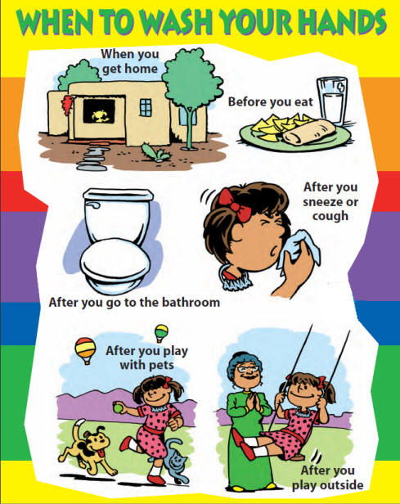

Sneeze and cough into your elbow!

