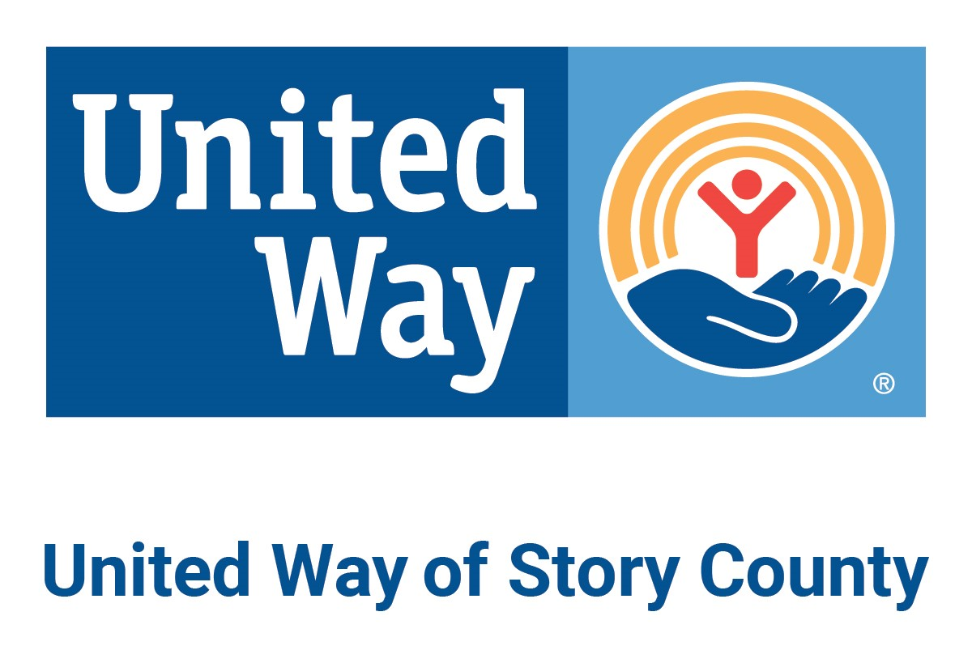

Resources Specifically for Immigrants or
Other Internationals

Story County Resources:

CLASSES (ENGLISH-LANGUAGE-LEARNER AND OTHERS)

Ames Interfaith Refugee Alliance
Due to COVID-19, AIRA had to suspend their ELL lessons. They plan to continue contacting the former refugees every week for the duration of the shelter-in-place to see how AIRA might help them. Email Diane Birt if you have questions: dbirt.ames@gmail.com

Christ Community Church, International Programs:
Keep posted for updates.

DMACC Hunziker Center, Ames - ELL classes:
DMACC ELL & High School Equivalency classes will be offered virtually only for those students enrolled before COVID-19 closures. Keep posted for updates.

Memorial Lutheran Church’s International Student Ministry.
Most regular programming is suspended currently. However, the Idioms class is continuing through Google Hangouts, Monday, Tuesday, Wednesday, Thursday, 10 am or 2 pm. Contact Judy Newhouse for more information: ism.mlchurch@gmail.com

YWCA - Ames @ ISU (United Way partner agency)
(515) 294-1663 / Facebook: “YWCA Ames-ISU”.
The YWCA Ames at ISU will continue all “Engaging International Students & Scholars” programs for the Spring Semester virtually. Current class offerings:
1. Weekly meeting
2. Zumba training
3. International Cultural Video uploads

Please email Chinmayee, Global Outreach Coordinator, for details: cmankar@iastate.edu

Other YWCA Programs:
If you would like to volunteer for our virtual International Friendship Fair series live on Facebook, message us!
If you would like to participate virtually in our Talk Back student group to discuss social justice issues, message us!
Look for more information on our virtual Stand Against Racism on April 23rd-24th.

FINANCIAL ASSISTANCE DURING COVID-19

You are encouraged to apply for unemployment benefits if possible. The criteria and application form are here: www.iowaworkforcedevelopment.gov/file-claim-unemployment-insurance-benefits

Ames United Church of Christ
515-232-9323 / eileen@amesucc.org
Funding is available to help pay the bills (rent, utilities, medical) for those experiencing income or job loss due to COVID-19. The payee needs to be able to accept a credit card via phone or the internet. Contact Pr. Eileen Gebbie at either eileen@amesucc.org or 515-232-9323. No SSN required. No ID required.

Christ Community Church
515) 232-2765 / info@ccames.org - Financial assistance is available. No SSN required. More details coming.

Good Neighbor Emergency Assistance (United Way partner agency)
515-296-1449 / assistance@gnea.org - Good Neighbor has made a decision to move applications for assistance from in person to phone and email applications at this time. They prefer people call or email on Mondays and Thursdays, but will be monitoring email and taking calls any time they can. Food vouchers are being distributed for emergency use only at this time. Again, a phone or email application informs their decisions and pick up of the vouchers will be from a medically safe and secure location. No SSN or state identification required; other forms of photo ID are fine.

Iowa State University Student Services
Email: studentassistance@iastate.edu - For any ISU students in need of assistance (financial or otherwise), the Student Services team would be happy to connect with you to discuss resources that may be available. The Student Services office would work closely with the International Students & Scholars Office (515-294-1120 | brendano@iastate.edu ) to assist you.

Story County Community Services
515-663-2930 / communityservices@storycountyiowa.gov - All County services will remain operational and available to the public either online or via phone or email. The Community Services office at 126 South Kellogg Ste 001 in Ames is closed to the public as of noon on March 18. They are only able to help immigrants/internationals with green cards. However, they can provide a denial letter to others. Often this denial letter is required by other funding agencies.

St. Patrick’s “Good Samaritan” Financial Assistance program (Nevada, IA)
515-382-2974 - This program is for residents of eastern Story County: Must live on east side of interstate (Cambridge, Collins, Colo, Fernald, Maxwell, Mc Callsburg, Nevada, Roland, Zearing). Provides rent and utility assistance every 6 months (up to $200). Provides gas assistance (for work or medical appointments only) every 3 months. Students are not eligible for the program. During COVID-19, assistance is provided by phone - please call! Denials are not currently required; landlord and utility company information is still required for those requesting rent or utility assistance; driver's license is required for those requesting gas assistance. SSN requested but not required.

St. Thomas' "Love Your Neighbor" program
515-292-3810 / tom@staparish.net - Their office will be closed as of March 18 and the building will likely close within a day or so of that. They will try to continue to serve "Love Your Neighbor" clients by phone, email, or mail. No SSN required.

The Salvation Army
515-233-3567 / cari.mcpartland@usc.salvationarmy.org -All assistance is by appointment only. Starting Monday, March 30 clients can call to schedule phone interviews for homelessness prevention dollars. No SSN required.

OTHER RESOURCES
* For Food/Hunger resources, EVERYONE is eligible for assistance regardless of status in the USA. Please go to the United Way document to learn of open hours and more: docs.google.com/document/d/1qWHaz-FqdZybF9SXcKflOgiBJW2rO605-M2gy13BTZw
* For Mental Health resources, including counseling in other languages, please go to: drive.google.com/file/d/17VrjiD_PULl2agn-E3cagNSywXX7QNJt/view
* Assorted other:
AMOS-Immigration
The Ames-based group is currently conducting a needs assessment. Contact Rick Exner with questions: rickexner2@gmail.com

Central Iowa Community ID (a project of the Story County Coordination Committee and the Marshall County Community Response Coalition):
If you need an ID, you may find that documents you do have make you eligible for the Central Iowa Community ID card.* Acceptable documents include foreign passports and matrículas and expired Iowa driver’s licenses. For more information, go to www.communityid.org or call (515) 599-8149.

*The Central Iowa Community ID, following the FaithAction model, is for residents who may have limited access to government issued forms of identification. Note: It is not a government issued form of ID or a driver’s license, but a verifiable form of identification that says you are part of our community. It can be used as a tool by law enforcement to better identify, serve, and protect you, and may be accepted by health centers, schools, businesses, and other community agencies--depending on the policy of each.

State & National Resources:

Betancourt Macias Family Scholarship Foundation
This Foundation is launching a GoFundMe fundraiser to raise funds to support undocumented families and individuals during these times of crisis. Please fill out this survey to apply for funds. The amount we can provide each person is based on the donations we receive and the amount of requests we receive. Go to https://www.undocuscholars.com/
to donate or to apply for funds.

COVID-19 Information and Resources from the Refugee Alliance of Central Iowa (IN MANY LANGUAGES):
https://www.refugeeallianceofcentraliowa.org/covid19-information?fbclid=IwAR3wKaZRWfC40Vf1NbOzx6_iLJu8CMKjA_AWHCeEFt9i0iRAzsI2ftqouzY

Expensify.org
Offers up to $50 of reimbursement for SNAP recipients: https://www.expensify.org/hunger?fbclid=IwAR0OSRPNwRjTTwx8E0RyqiG7VvvBWRWCjr9LolJEnQGxvO7TFmWaXDz3csc

Iowa Office of Latino Affairs:
This office has put together a list of assorted resources to assist during the pandemic and beyond: https://docs.google.com/document/d/1Of6IZKjAJwD6Wkz_vSUDhhtuYasCyE5kVdAqA_VdVwA/edit

UndocuScholars.com
This organization has put together a list of assorted resources (national and state-specific). Visit https://docs.google.com/spreadsheets/u/1/d/18p9OSlLpSYanIoUC-gEbhVbRMYVUfw4wyrixa9ekGdc/htmlview?usp=sharing

FAQ's for immigrants from Sonia Parras Law Office

